Group 27
PS/2021/171 - SITUBANDARA S.N.S.B.T.C.
[Company name]
Group 27
Highway Ticketing System
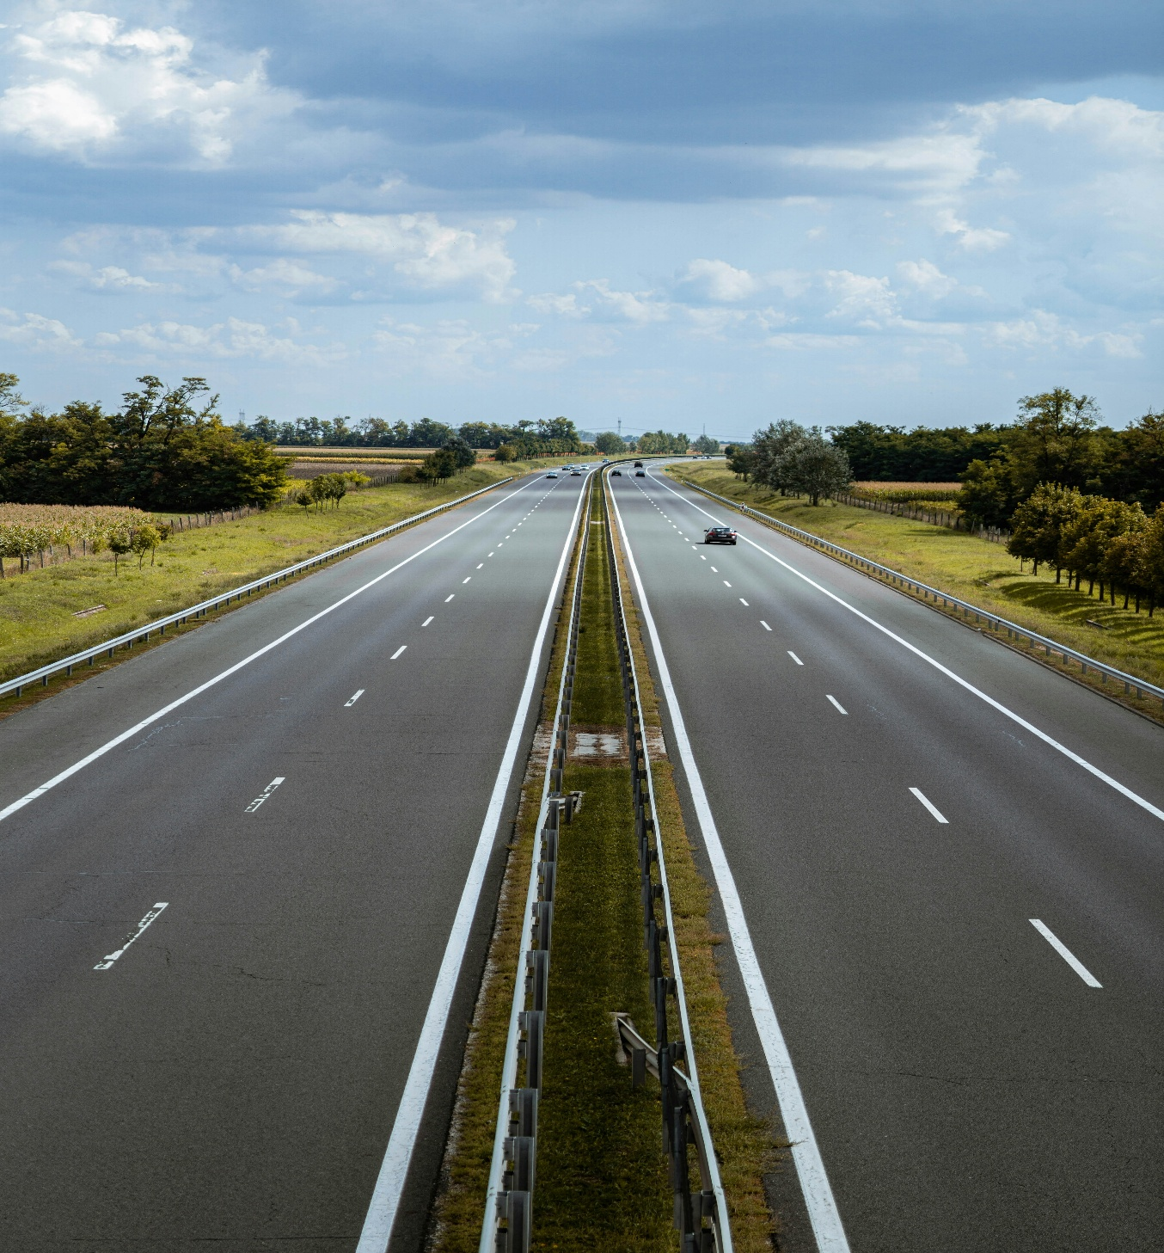
- Form1 (Logging & Registration).
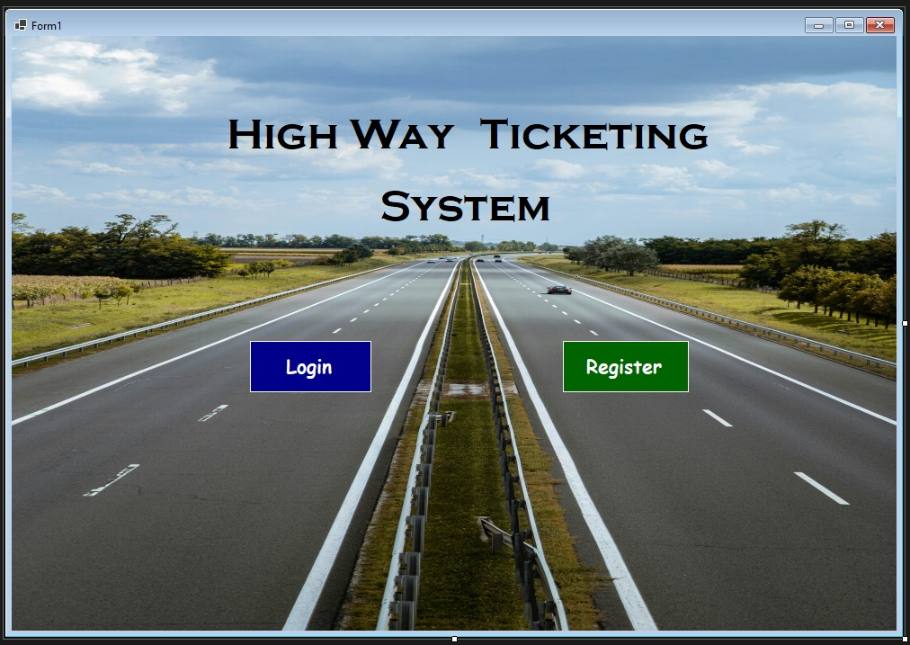

🏠 Welcome Page
This is the main entry page of the Highway Ticketing System. It has two buttons: "Log" and "Register".
- New employees can click "Register" to create their account by entering their personal details and setting up a password.
- Existing employees can click "Log" to sign in using their User ID and Password to access the system.
This ensures only authorized employees can manage vehicle entries and billing.

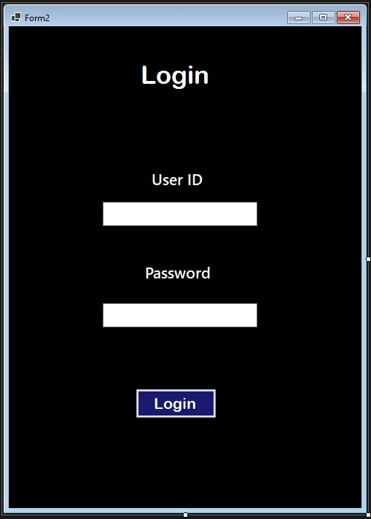
- Form2(Logging Page).

🔐 Login Page
This is the login page of the Highway Ticketing System. Existing employees can access the system by entering their User ID and Password in the provided fields. After entering the correct details, clicking the "Login" button will take them to the main system dashboard, where they can perform their entrance or exit point duties. This ensures secure access and protects the system from unauthorized use.

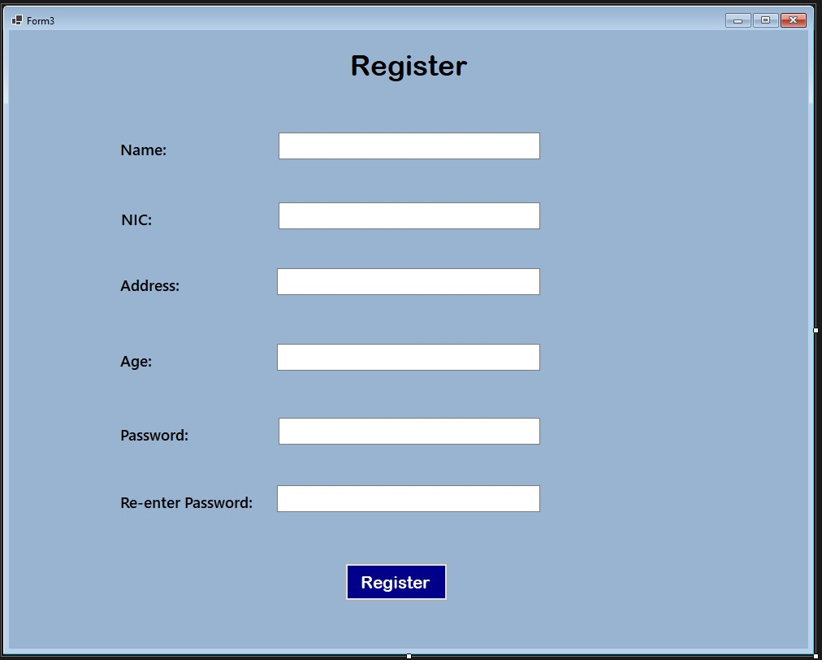
- Form3(Ticketing Employee Registration).

📝 Registration Form
This is the registration page of the Highway Ticketing System. New employees can create their account by entering their personal details, including Name, Address, NIC, Age, and by creating a Password. After submitting the form, they will receive a User ID, which they can use along with their password to log into the system. This process ensures that only registered employees can access and operate the system.

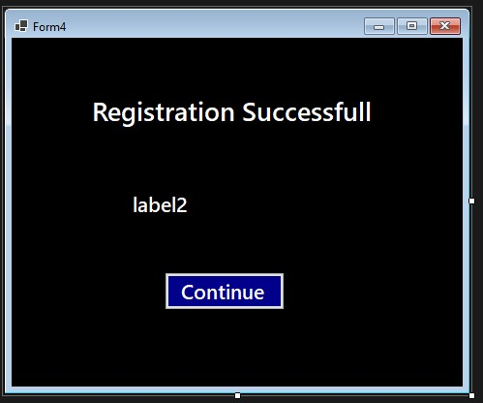
- Form4(Successful Message with User ID).

✅ Registration Success
This page confirms that the new employee has been successfully registered in the Highway Ticketing System. It displays a "Registration Successful" message along with the newly assigned User ID. Employees should carefully note down this User ID, as it will be required along with their password to log into the system.

- Form5(Entrance details & Exit details).
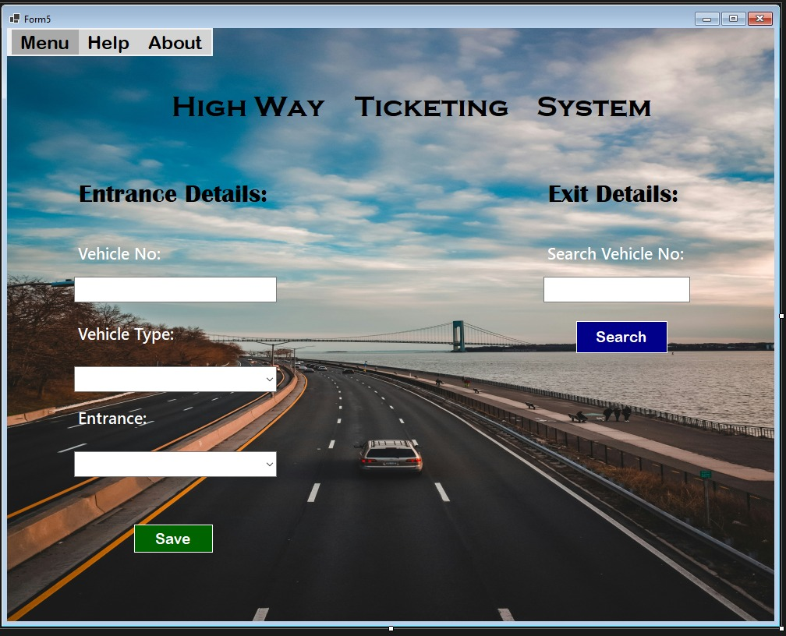

🚦 Vehicle Management Page
This page serves as the main workspace for employees after logging in. Here, employees at the entrance point can enter vehicle details such as Vehicle Number, Vehicle Type, and Entrance Point Name to register vehicles entering the highway. Employees at the exit point can search for vehicles by entering the Vehicle Number to retrieve entry details and prepare for billing.

Additionally, this page includes a menu button, which allows employees to navigate to other important pages of the system, as shown in the below screenshot. This makes managing entrance registrations, exit billing, and accessing other features simple and efficient.

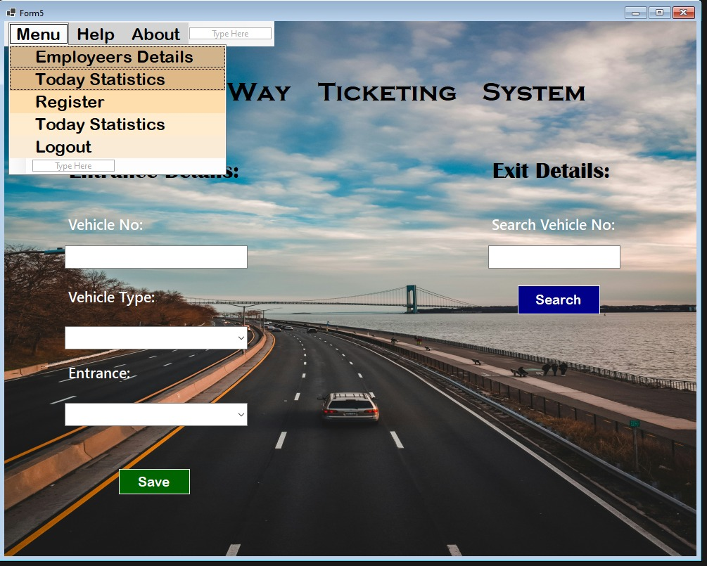

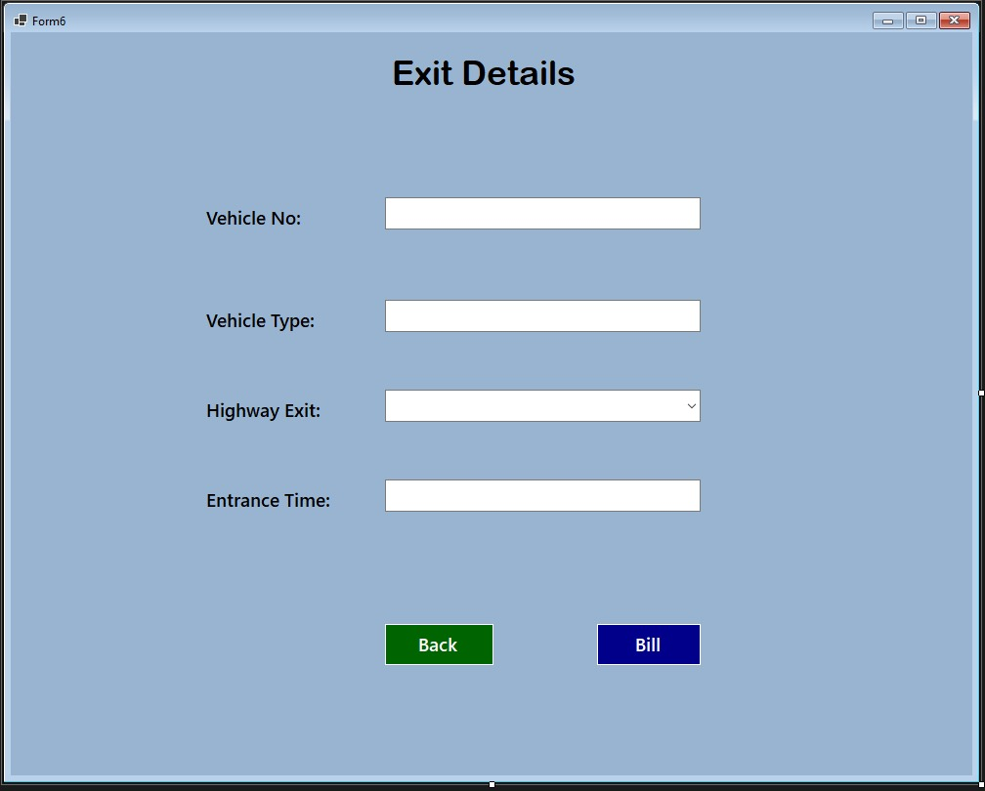
- Form6(Exit Details).

🧾 Exit Details Page
This page is used by employees at the exit point to finalize the vehicle’s journey on the highway. It displays key details such as Vehicle Number, Vehicle Type, Highway Exit, and Entrance Time. Here, the exit employee can confirm the vehicle’s exit information before generating the bill. This ensures that each vehicle is properly tracked from entrance to exit, supporting accurate toll calculation and billing. The page also includes menu options, as shown in your screenshots, to navigate to other parts of the system.

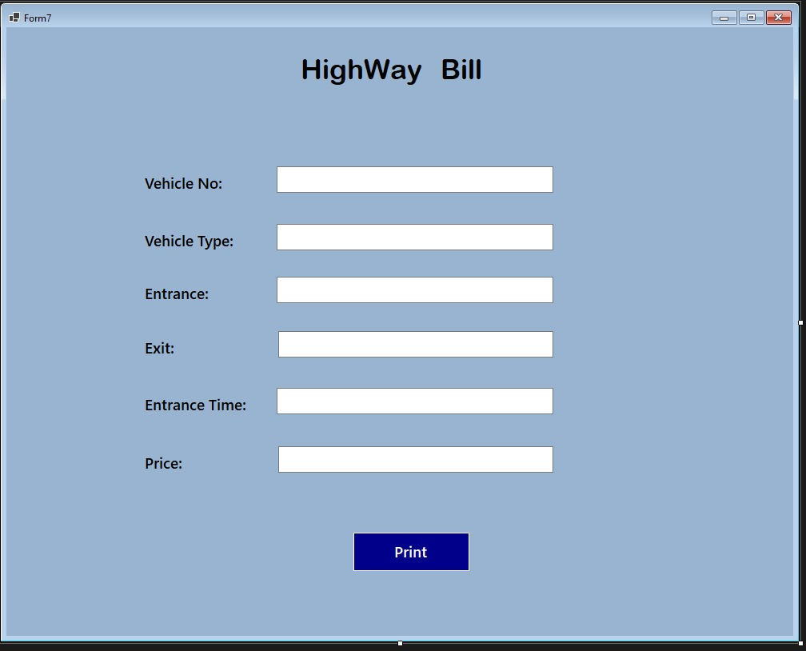
- Form7(Billing Form).

💵 Highway Bill Page
This page allows the exit point employee to generate the final bill for a vehicle exiting the highway. It displays all necessary billing details and provides a "Print" button so the employee can print a copy of the bill and give it to the driver. This ensures the vehicle is properly charged for its highway usage before leaving the system.

- Form8(Employee Details).

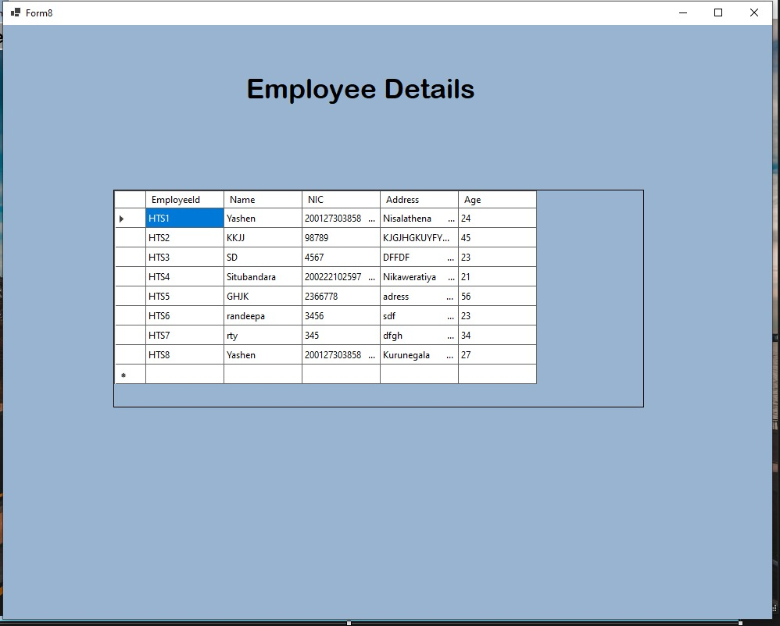

👥 Employee Details Page
This page displays the details of all registered employees in the Highway Ticketing System. It allows you to view information such as employee names, addresses, NIC numbers, and other registration data. This helps in keeping track of who is authorized to use the system and ensures proper management of employee records.

- Form9(help Section).
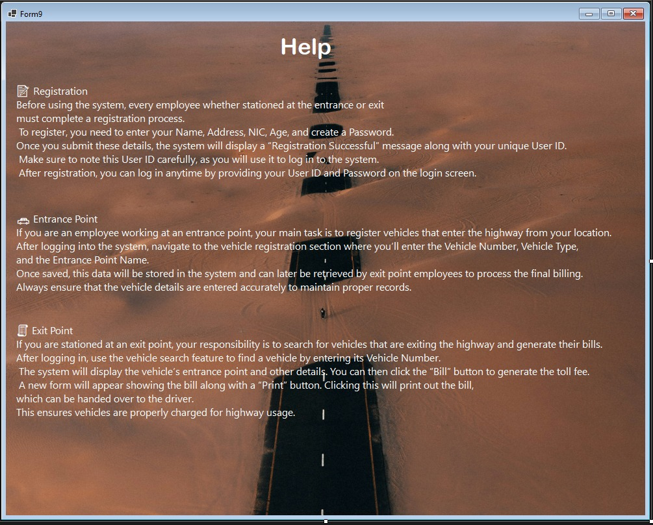

❓ Help Section
This page provides helpful guidance on how to use the Highway Ticketing System. If an employee encounters any difficulties or is unsure how to perform a task—such as registering, logging in, entering vehicle details, or generating bills—they can visit this Help Section to find clear instructions and solutions. It ensures employees can quickly resolve issues and continue their work without delays.

- Form10(About Section).
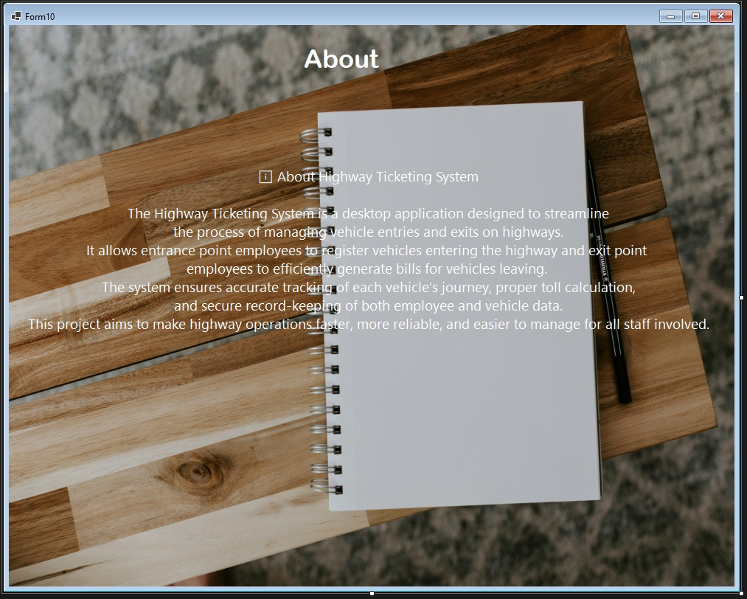

ℹ️ About Section
This page provides a brief overview of the Highway Ticketing System, helping new employees or visitors understand what the system is and how it works. It explains the main purpose of the application—managing vehicle registrations at entrance points and generating bills at exit points—to ensure smooth and accurate highway operations. This section is a quick introduction for anyone new to the system, giving them a clear idea of its features and benefits.

- Form11(Statistic Form).
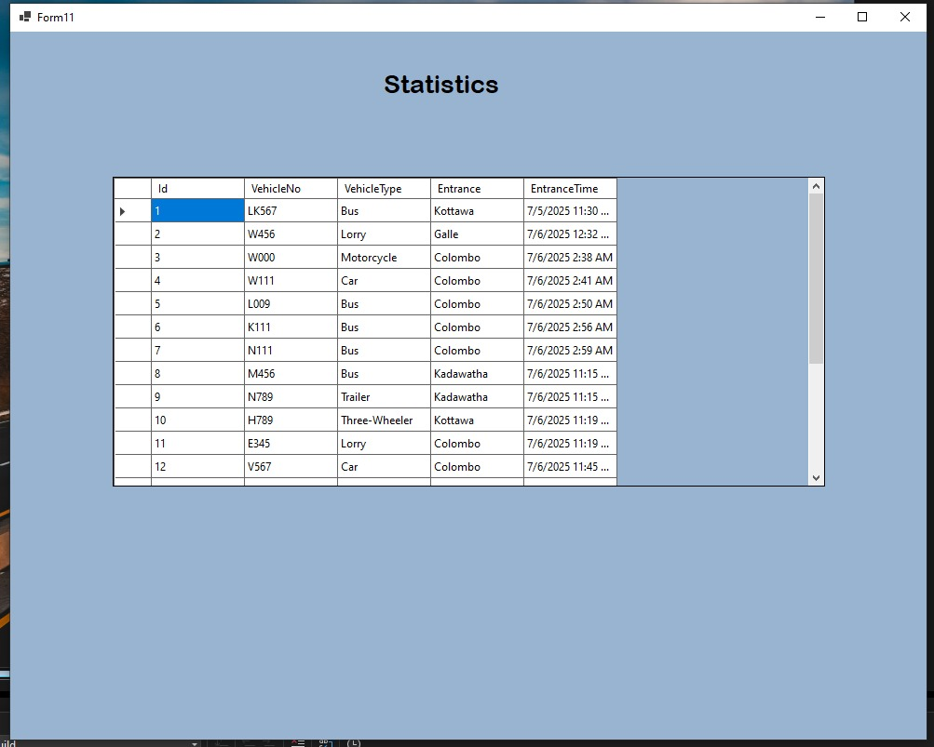

📊 Statistics Page
This page displays important statistics and records of highway usage. It includes details such as the Vehicle Number, Entrance Point, Exit Point, and Vehicle Type or Name, giving a clear overview of traffic flow and vehicle movements on the highway. This helps employees and administrators monitor operations, track vehicle patterns, and ensure accurate record-keeping for reporting and analysis.

- Group Members

PS/2021/167-DGDP Sathsara.
PS/2021/168-TMYR Thennakoon.
PS/2021/171-SNSBTC Situbandara.
PS/2021/173-JAAR Jayaveera.

Thank you !

